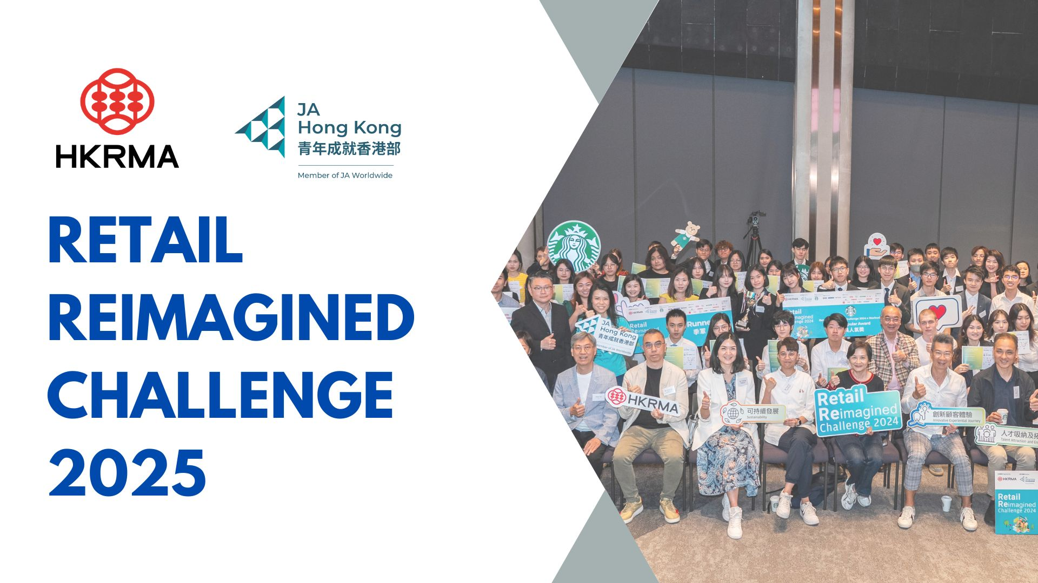

|  |  |  |
| --- | --- | --- |
| **PARTICIPATION FORM (Fill in Part I & II)**  **(Deadline: 24 January 2025)** | | |
| **Part I: Company Information** | | |
| Company Name | (English) |  |
|  | (中文) |  |

|  |  |  |  |  |
| --- | --- | --- | --- | --- |
|  |  |  |  |  |

|  |  |
| --- | --- |
| Brand: |  |
| Contact Person: | (Mr./Ms./Mrs.) |
| Title: |  |
| Tel: |  |
| Email |  |

|  |  |  |
| --- | --- | --- |
| Participating Type: |  | Silver Sponsor ($10,000) |
|  |  | Gold Sponsor ($25,000) |
|  |  | Diamond Sponsor ($50,000) |
|  | Not available | Platinum Sponsor ($80,000) |

|  |  |  |  |
| --- | --- | --- | --- |
| **Booking Procedures** | | | |
| 1. Companies have to complete and /email this enrollment form and company logo (AI and JPEG format) to HKRMA. Contact: Yuki Luk (yuki.luk@hkrma.org / Tel: 2892 1729). 2. Full payment should be settled by cheque payable to “Hong Kong Retail Management Association Ltd.” within 2 weeks upon the submission of the enrollment form. 3. Please send the cheque to HKRMA, 7/F., First Commercial Building, 33-35 Leighton Road, Causeway Bay, Hong Kong, together with the signed order form. 4. No cancellation will be accepted after submission of enrollment form. | | | |
| Date: |  | Signature & Company Chop: |  |

|  |
| --- |
| **Part II:** **Business Challenge**  The challenge can be a specific business case of your company or an industry-wide pain point that is of your concern. We will present your business challenge to students for their idea generation. |
| **1. Business Challenge in ‘Competitive Retail’ (if any)**  With the evolving landscape of retail market driven by shifts in consumer behavior and increasing competition, particularly from businesses in the GBA (Greater Bay Area), retailers must adapt swiftly and reposition their retail strategies at the current juncture of retail transformation. This includes differentiating product offerings, expanding customer segments, enhancing brand equity, forging strategic partnerships and reducing operating costs. Raising competitiveness is essential for future success. |
| **Your Challenge in ‘Competitive Retail’:** |
| **2. Business Challenge in ‘Experiential Retail ’ (if any)** Experiential retail is the future because customers place greater emphasis on unique and personalized experiences from retailers. Companies must be innovative in building stronger, longer lasting and more interactive customer relationships through experiential journeys that add unique value at every touchpoint. This approach is critical for fostering customer loyalty and driving ongoing engagement. |
| **Your Challenge in ‘Experiential Retail ’ :** |
| **3.** **Business Challenge in ‘Sustainable Retail’ (if any)** Sustainability has become a pressing issue due to intensifying global environmental and social challenges. Consumers are increasingly concerned about how companies incorporate Environmental, Social, and Governance (ESG) principles in their operations, including waste management, energy efficiency and ethical sourcing and supply chain management. For retailers, adopting sustainable practices is pivotal for achieving future success. |
| **Your Challenge in ‘Sustainable Retail’ :** |